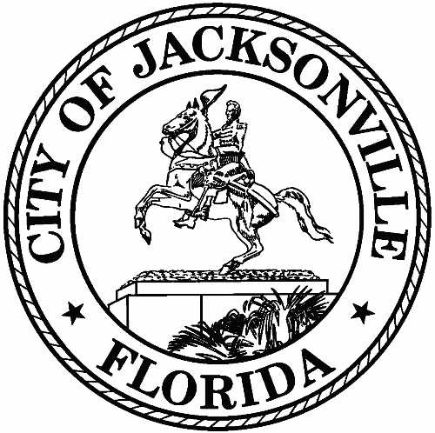
City of Jacksonville
1st Floor - Council Chamber 117 W. Duval Street

Meeting Minutes
Member to Member Meeting

Friday, May 20, 2022
9:00 AM
In-Person Meeting

Safety and Crime Reduction Commission

Meeting Convened: 9:07 am Meeting Adjourned: 10:19 am

Attendance:
Chair: Dr. Constance Hall; Vice Chair: Ronnie King; Administrator: Dr. Nicoa Garrett

Commissioners: Frank Denton; William Gentry; Shelley Grant; Mark Griffin; Ellen Glasser; Vicki Waytowich; Shamika Baker Wright; Tom Geismar

Liaisons to the Commission: City Council President Samuel Newby; Katoia Wilkins; Stephen Siegel; Harry Wilson; Paul Restivo

Guest: Mia Hobdy; Jessica Denson; Chiquita Moore; Tanya Washington

- Call to Order –
Chair Hall welcomed everyone to the Safety and Crime Reduction Commission (SCRC) to the meeting.
- Roll Call –
Quorum Verified
- Remarks
City Council President Samuel Newby informed the commissioners that the $336,000 (sponsored by City Council President Newby and City Council Member Reggie Gaffney) for the SCRC Jacksonville Rise Up Grant was approved by the City Council.
- Approval of Meeting Minutes
The April 2022 SCRC Member to Member meeting summary was approved by the
SCRC Commissioners.
- Administrator Report
Dr. Garrett reminded the commissioners that the SCRC Mental Health Awareness Campaign event will be Saturday, May 21, 2022, at the Philippian Community Church, 7578 New Kings Road. Dr. Garrett provided an outline of the tentative timeline for the Rise-Up Jacksonville Grant and a sample of the grant drafted application. The Rise-Up Jacksonville Grant will award $9,000 to approximately 37 small grassroots non-profits throughout Duval County.
- Newtown Success Zone
Mia Hobdy, Executive Director, Edward Waters University, New Town Success Zone,
gave an overview of the New Town Success Zone’s purpose and its programs in the
New Town Area.
- JSO Crime Mapping
Assistant Chief Paul Restivo provided the SCRC commissioners with a detailed overview of the Jacksonville Sheriff’s Office Crime Mapping webpage. Please visit https://www.jaxsheriff.org/Resources/crime-mapping.aspx to access the JSO Crime Mapping.
- Targeted Neighborhood Project
No Report.
- Keeping it in Context-
No Report.

- Subcommittee Update
Commissioner Frank Denton informed the SCRC commissioners that he met with Dr. Irvin PeDro Cohen, Executive Director, Local Initiatives Support Corporation (LISC) Jacksonville, and provided an overview of the meeting.
- Public Comments – 3 Minutes Each
None

With no further business, Chair Hall adjourned the meeting.

Summary: Jessica Denson - Neighborhood Service Office – Jcdenson@coj.net - 904.255.8260

