

630-CITY MEDIUM TREE LIST

**Eagleston Holly (*Ilex* x *attenuata* ‘Eagleston’)**

Evergreen (does not drop leaves in winter) 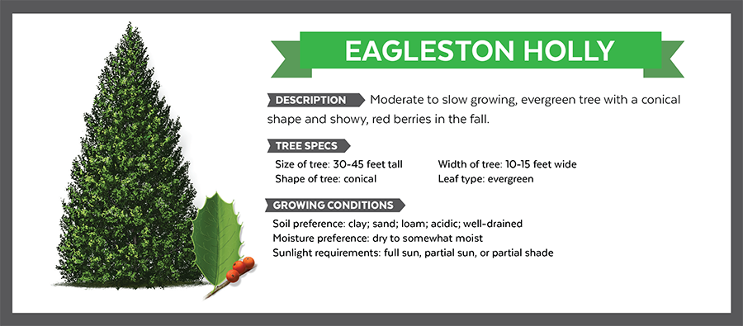

A medium sized tree that is a hybrid between holly species that has a dense, green canopy and produces red berries. Can be in pyramidal form or pruned up with a clear trunk.

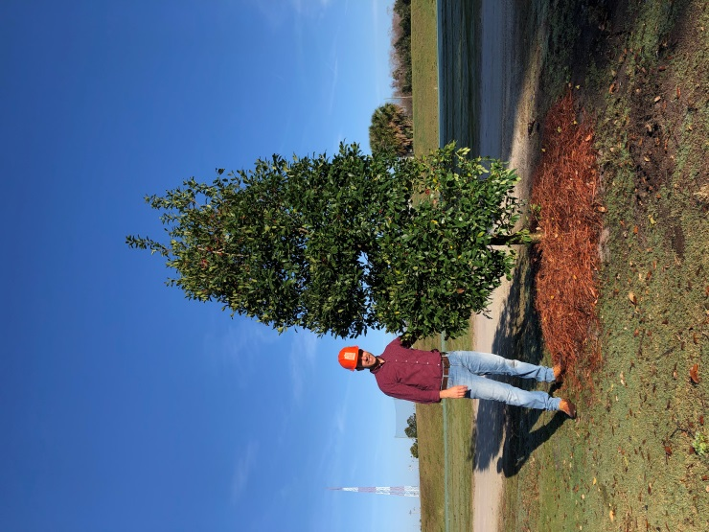

**River Birch (*Betula nigra*)**

Deciduous (drops leaves in winter)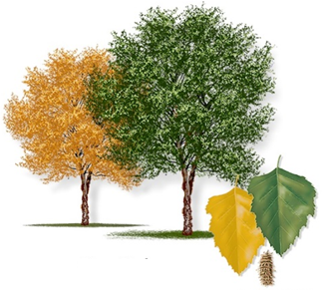

A medium sized tree with very flaky, showy bark that has a very central leader form and sometimes grown in groups of three. Has fall color and non-showy flowers that bloom in mid spring.

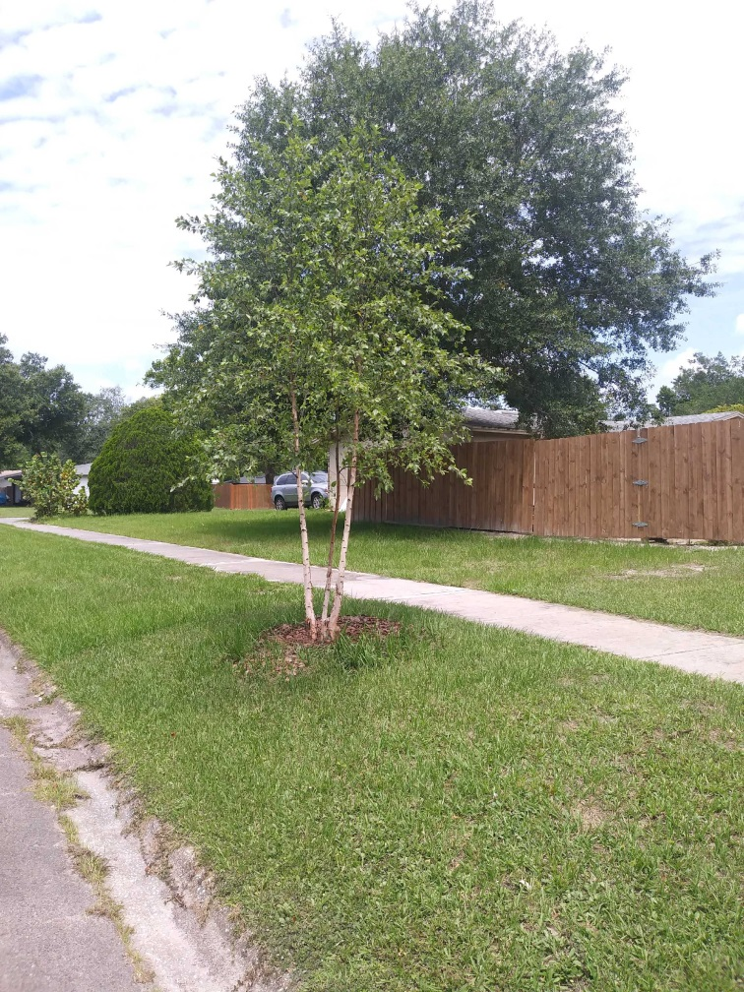

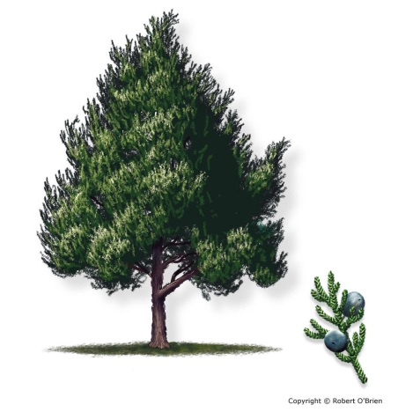**Southern Red Cedar (*Juniperus virginana*)**

Evergreen (does not drop leaves in winter)

A medium sized, slow growing tree that has small scale-like leaves and produces small bluish berries. The cedar has a distinct smell to the wood and a thin reddish bark.

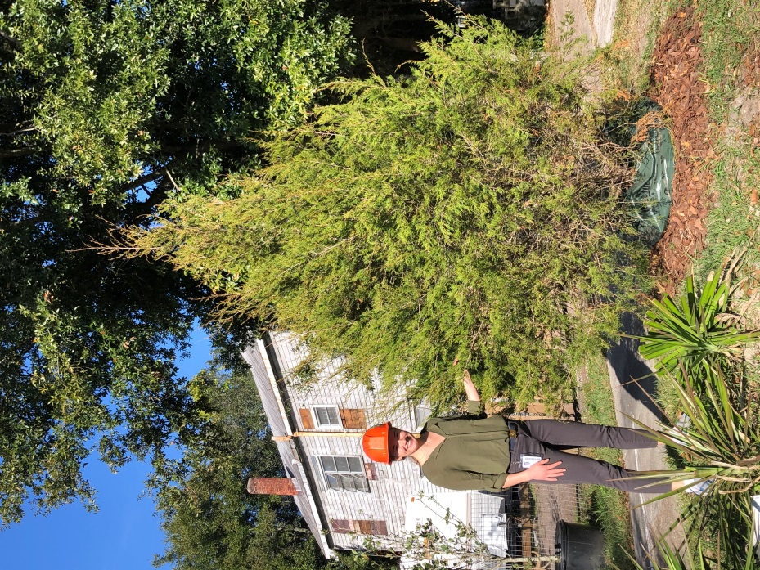

**Sweetbay Magnolia (*Magnolia virginiana*)**

Evergreen (does not drop leaves in winter) 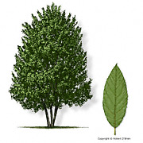

A medium sized magnolia tree that has large green leaves with silvery undersides and produces showy white flowers in the late spring/early summer.

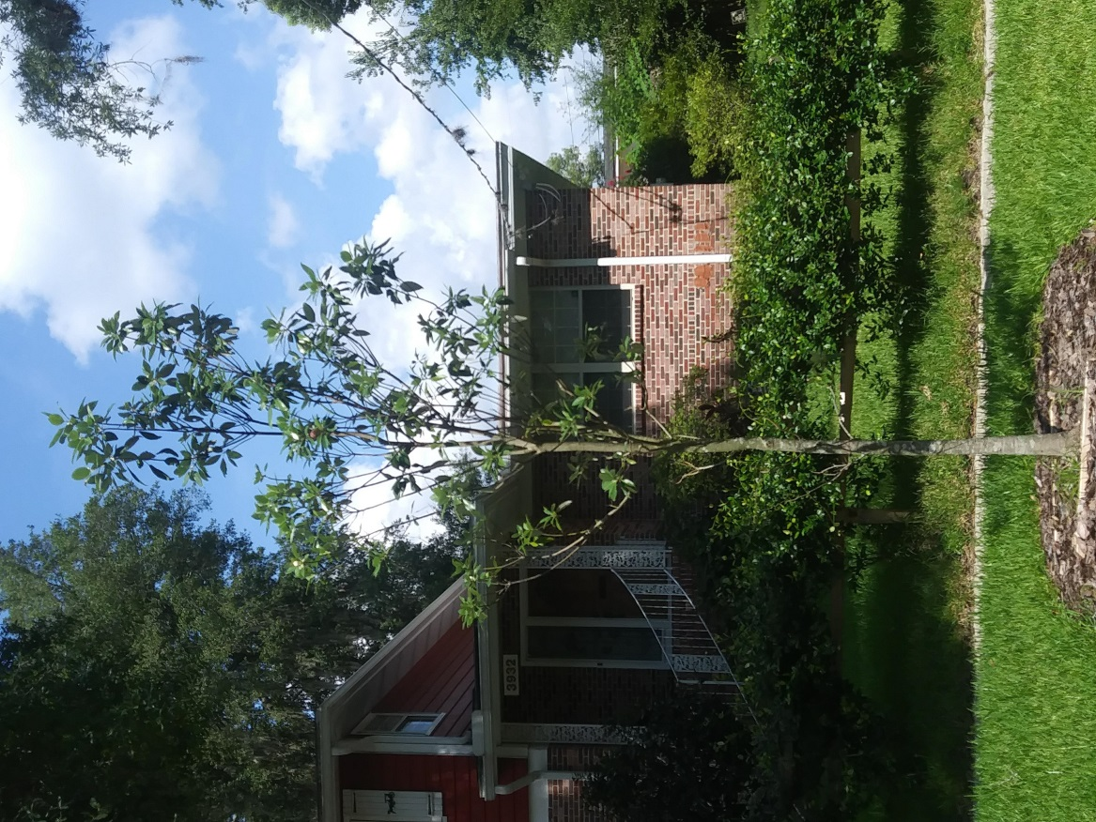

**Winged Elm (*Ulmus alata*)**

Deciduous (drops leaves in winter) 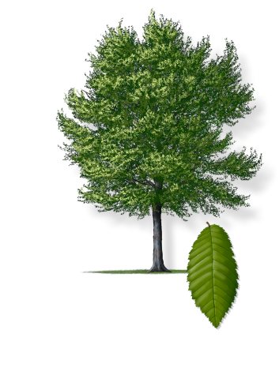

A medium to large tree with green leaves and a distinct ‘winged’ appearance on the branches.

