Duval County

CHAIR
SENATOR AARON BEAN
VICE CHAIR
REPRESENTATIVE JASON FISCHER

Legislative Delegation

SENATORS
AARON BEAN
AUDREY GIBSON

REPRESENTATIVES
CORD BYRD
KIMBERLY DANIELS
TRACIE DAVIS
JAY FANT
JASON FISCHER
CLAY YARBOROUGH

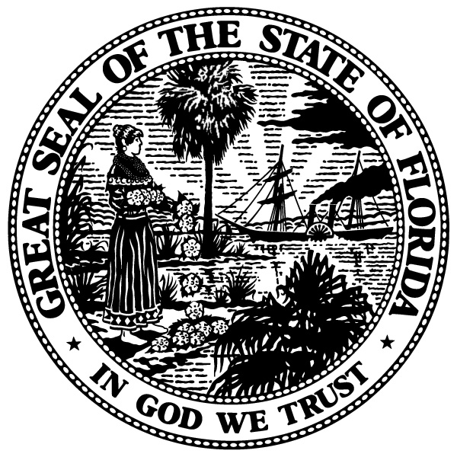

Minutes
Delegation Meeting
Wednesday, January 17, 2018
8:00 a.m.
Room 401-S, Senate Office Building
Tallahassee, FL

Chair Bean called the meeting to order at 8:00 a.m.

Members Present- Chair Bean, Vice Chair Fischer, Senator Gibson, Representative Byrd, Representative Daniels, Representative Fant and Representative Yarborough; Absent- Representative Davis

The Chair said that this meeting was about communication and coordinating appropriations for Northeast Florida. This first topic of conversation was education funding in Northeast Florida. Janet Owen from the University of North Florida was the first speaker. Janet thanked the Delegation for meeting and mentioned the projects that UNF is hoping to get funded to help the university update some buildings.

Chair Bean then moved on to the topic of healthcare appropriations. The first speaker was Debbie O’Neal with the Mental Health Resource Center. Debbie spoke about the work of Mental Health Resource Center and asked for funding to open a second site to provide more services. The next speaker was, Layne Smith with the Mayo Clinic. Layne thanked the Delegation for previous year funding but mentioned the lack of cancer research funding in Northeast Florida. The next speaker was Dr. Vicki Waytowich from the Partnership for Child Health. Dr. Waytowich mentioned the appropriations requests for this upcoming year and how they hope to expand access of mental healthcare to children with complex mental issues.

The City of Jacksonville was represented by Mat Forrest and Mark Pinto who spoke on the city’s six appropriation requests for this Session. The majority of these requests focus on water projects and public safety.

The Chair then spoke on funding for community colleges and the cuts that have been made for those establishments. He then spoke about funding the St John’s River and receiving Florida Forever dollars in Northeast Florida to fund environmental projects.

Representative Byrd then spoke on his appropriation priorities for the Session. These priorities include funding for the Five Star Veteran’s Center, Mayport Dock revitalization, Neptune Beach projects, and the Dolores Barr Weaver program.

Vice Chair Fischer then spoke on his appropriation priorities for the Session. These priorities include funding for KIPP, Communities in Schools, Jewish day school security upgrades, and Operation New Hope.

The next Delegate to speak was Representative Fant. Representative Fant spoke about the “Sanctuary City” bill and how it passed out of the House and was hoping that Chair Bean could speak to its success or failure in the Senate. Chair Bean said that the bill has a challenge in the Senate and it will need to be worked on for it to pass out of the Senate committees.

Representative Daniels also spoke on her appropriation priorities which include: COPS grant, Shot spotter, gun violence prevention, substance abuse prevention, and YMCA funding.

Next, Representative Yarbrough spoke on his priorities. These priorities include pedestrian safety, FSCJ STEM center, Beaver Street Enterprise center, and UNF building upgrades.

Senator Gibson then spoke on her priorities for the Session. These priorities include funding for AGAPE Health Clinic, family support services, Five Star Veterans Center, and Edward Water’s College.

Chair Bean then mentioned that Suzanne Goss from JEA, Eric Smith, and Michael Stewart from the JAA were present. Senator Gibson then thanked everyone for all of their hard work after the hurricanes.

There being no further business the meeting adjourned at 8:32 a.m.

This is not a verbatim transcript but a summary of the proceedings. A recording is on file in the Delegation office and posted online on the Delegation website.

