Duval County

CHAIR
SENATOR AARON BEAN
VICE CHAIR
REPRESENTATIVE JASON FISCHER

Legislative Delegation

SENATORS
AARON BEAN
AUDREY GIBSON

REPRESENTATIVES
CORD BYRD
KIMBERLY DANIELS
TRACIE DAVIS
JAY FANT
JASON FISCHER
CLAY YARBOROUGH

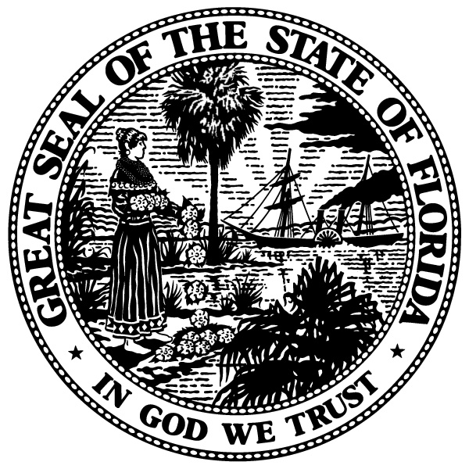

Delegation Meeting
January 17, 2018
Room 401-S, Senate Building
Tallahassee, FL
8:00 a.m.
A. Call to order and opening remarks, Chair Bean
B. Discussion of appropriation priorities for Duval
C. Additional items not on agenda, if time permits
D. Public comment
E. Announcements
F. Adjourn

