Duval County

CHAIR
SENATOR AARON BEAN
VICE CHAIR
REPRESENTATIVE JASON FISCHER

Legislative Delegation

SENATORS
AARON BEAN
AUDREY GIBSON

REPRESENTATIVES
CORD BYRD
KIMBERLY DANIELS
TRACIE DAVIS
JAY FANT
JASON FISCHER
CLAY YARBOROUGH

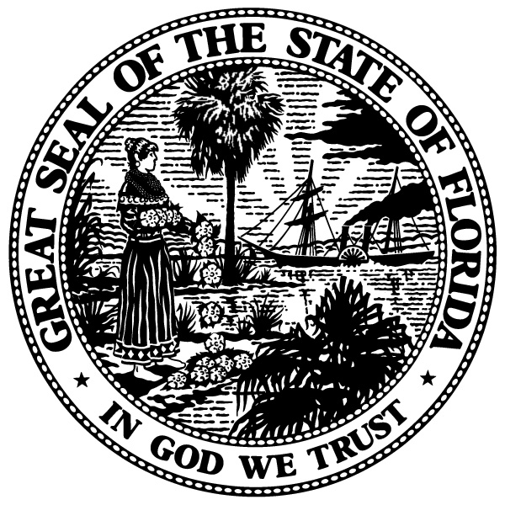

FOR IMMEDIATE RELEASE Contact: Lenae Voellmecke
(904) 630-1680
lvoellmecke@coj.net

SENATOR AARON BEAN,
DUVAL COUNTY LEGISLATIVE DELEGATION CHAIR,
ANNOUNCES MEETING

JACKSONVILLE, FL., JANUARY 12, 2018 – State Senator Aaron Bean, Chair of the Duval County Legislative Delegation, announces the Duval Delegation will meet Wednesday, January 17, 2018 from 8:00 a.m. - 8:30 a.m. The meeting will be held in Room 401-S, Senate Office Building, Tallahassee, FL 32399.

The purpose of the meeting is for the delegation members to discuss Senate and House issues relating to the Delegation and appropriations.

All Duval Legislative Delegation meetings are open to the public. Anyone requiring additional information should contact Lenae Voellmecke, Delegation Coordinator at (904) 630-1680.

###

