Duval Delegation Contact List
Senator Aaron Bean
District 4
Tallahassee Office
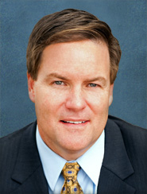
306 Senate Office Building
404 South Monroe Street
Tallahassee, FL 32399-1100
(850) 487-5004

District Office
Duval Station
13453 North Main Street, Suite 301
Jacksonville, FL 32218
(904) 757-5039

Legislative Assistants:
Dee Alexander, Joseph Endicott, and Austin Nicklas

Committee Assignments:
Communications, Energy, and Public Utilities - Chair
Appropriations Subcommittee on General Government - Vice Chair
Community Affairs – Vice Chair
Appropriations; Appropriations Subcommittee on Criminal and Civil Justice
Criminal Justice; Environmental Preservation and Conservation
Military and Veterans Affairs, Space, and Domestic Security

Senator Audrey Gibson
District 6

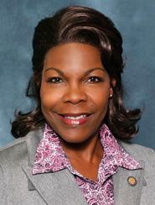
Tallahassee Office
405 Senate Office Building
404 South Monroe Street
Tallahassee, FL 32399-1100
(850) 487-5006

District Office
101 East Union Street, Suite 104
Jacksonville, FL 32202
(904) 359-2553

Legislative Assistants:
Farisha Hamid and Teresa Williams-Elam

Secretary: Jerome Maples

Committee Assignments:
Military and Veterans Affairs, Space, and Domestic Security - Chair
Appropriations
Appropriations Subcommittee on Transportation, Tourism, and Economic Development
Commerce and Tourism
Judiciary
Regulated Industries
Joint Legislative Auditing Committee

Representative Cord Byrd
District 11

Capitol Office
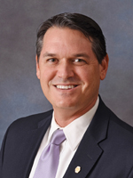
1101 The Capitol
402 South Monroe Street
Tallahassee, FL 32399-1300
Phone: (850) 717-5011

District Office
Suite B
1807 North Third Street
Jacksonville Beach, FL 32250-7491
Phone: (904) 242-3495
Or
Robert M. Foster Justice Center
76347 Veterans Way
Yulee, FL 32097-5404
Phone: (904) 548-9333

Legislative Assistant: Davis Bean
District Secretaries: Katherine Woodby and Christian Harvey

Committee Assignments:
Justice Appropriations Subcommittee - Vice Chair
Agriculture & Property Rights Subcommittee
Civil Justice & Claims Subcommittee; Health Quality Subcommittee
Judiciary Committee; Public Integrity & Ethics Committee
Select Committee on Hurricane Response and Preparedness

Representative Kimberly Daniels
District 14

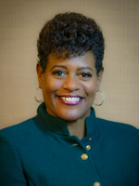
Capitol Office
1102 The Capitol
402 South Monroe Street
Tallahassee, FL 32399-1300
Phone: (850) 717-5014

District Office
Suite 106
11565 North Main Street
Jacksonville, FL 32218-4091
Phone: (904) 696-5928

Legislative Assistant: Karen Riggien
District Secretary: Clarence James

Committee Assignments:
Education Committee
Energy & Utilities Subcommittee
Justice Appropriations Subcommittee
Oversight, Transparency & Administration Subcommittee
Public Integrity & Ethics Committee
Transportation & Infrastructure Subcommittee

Representative Tracie Davis
District 13

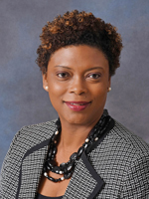
Capitol Office
1302 The Capitol
402 South Monroe Street
Tallahassee, FL 32399-1300
Phone: (850) 717-5013

District Office
Suite 402
101 East Union Street
Jacksonville, FL 32202-3065
Phone: (904) 353-2180

Legislative Assistant: Earl Jones
District Secretary: Kiaira Nixon

Committee Assignments:
Government Operations & Technology Appropriations Subcommittee
Health & Human Services Committee
Joint Legislative Auditing Committee
Oversight, Transparency & Administration Subcommittee
PreK-12 Quality Subcommittee
Public Integrity & Ethics Committee
Select Committee on Hurricane Response and Preparedness

Representative Jay Fant
District 15

Capitol Office
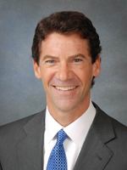
400 House Office Building
402 South Monroe Street
Tallahassee, FL 32399-1300
Phone: (850) 717-5015

District Office
Suite 104
4114 Herschel Street
Jacksonville, FL 32210-2200
Phone: (904) 381-6011

Legislative Assistant: Chesten Goodman
District Secretary: Lynne Holicky

Committee Assignments:
Education Committee
Government Accountability Committee
Government Operations & Technology Appropriations Subcommittee
Justice Appropriations Subcommittee
Local, Federal & Veterans Affairs Subcommittee

Representative Jason Fischer
District 16

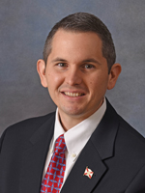
Capitol Office
1401 The Capitol
402 South Monroe Street
Tallahassee, FL 32399-1300
Phone: (850) 717-5016

District Office
Suite 2300
4130 Salisbury Road
Jacksonville, FL 32216-8033
Phone: (904) 332-7297

Legislative Assistant: Rachel Lockhart
District Secretary: Sadie Haire

Committee Assignments:
PreK-12 Innovation Subcommittee - Vice Chair
Education Committee
Energy & Utilities Subcommittee
Health Innovation Subcommittee
Joint Administrative Procedures Committee
PreK-12 Appropriations Subcommittee
Public Integrity & Ethics Committee

Representative Clay Yarborough
District 12

Capitol Office
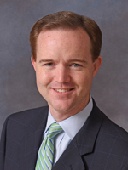
1401 The Capitol
402 South Monroe Street
Tallahassee, FL 32399-1300
Phone: (850) 717-5012

District Office
1615 Huffingham Road, Suite 1
Jacksonville, FL 32216-2792
Phone: (904) 723-5300

Legislative Assistant: Jennifer Contreras
District Secretary: Mamie Rubottom

Committee Assignments:
Government Operations & Technology Appropriations Subcommittee - Vice Chair
Criminal Justice Subcommittee
Health & Human Services Committee
Health Innovation Subcommittee
Joint Select Committee on Collective Bargaining
Oversight, Transparency & Administration Subcommittee

Updated: January 9, 2018

