**PSG Application Questions & Answers**

**Please click Mark as Complete when done with section to check that you have completed everything, and then click Save & Continue.**

**Week of June 4, 2018**

Am not able to log in any chance it has something to do with my role and access rights? Make sure you are using the same e-mail address to log in. If you are receiving a current PSG and have an AmpliFund account in the top right hand corner is you name. Click on it and you’ll see drop down menu. Then click on Applicant Portal. There is your application. See message from AmpliFund.

When an existing recipient logs in to AmpliFund who has already started their 2019 application, they will click their name in the top right corner (User Navigation) > Applicant Portal as shown in my screenshot below. Please note that the Applicant Portal settings can be set to on or off for each user. If one of your recipients is not seeing the Applicant Portal option in their User Navigation dropdown they will need to have their user settings updated to allow access. An Organization Administration at the Recipient organization will go to Administration > System Security > Users > click the pencil icon next to the user’s name, then check the checkbox next to the Applicant Portal Access option and click the Update button.

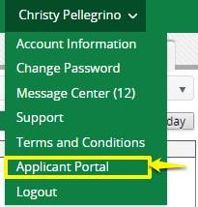

I thought I remembered hearing your boss or you say that a lot of the funds that people ask for in the grant are for salaries. Did I remember correctly? Yes, the majority of the funding request is for salaries and benefits; however, this is not a requirement.

Would you please provide me the dates, this fiscal year that our agency was on the Council Auditors List? Sure

I am trying to register on AmpliFund. It’s not showing a register to create a profile.

Can you help me on this? Do you already have an account?  I’ve attached the user guide just in case you need it.

**Week of June 11, 2018**

I am trying to download, “Budget Forms FY19-City Grant.xlsx” from the portal, but an error message keeps popping up.  Do you know why this is?  The same thing happens when I try to download, “Ceritfication of Additional Funding Sources.doc”. The error message you are getting relates to your error on your end; However, here are the documents is question.

John, what is the last sentence in red of this supposed to say (it's in the template).

Please and thank you.

**Section I – Agency Background & Experience**

Containing a description of the agency’s board (number of members, length of service of each member, and professional experience of each member), executive staff (e.g. executive director, chief executive or operating officer, chief financial officer), and the agency’s experience in the community and accomplishments.  This section may without limitation the agency’s mission, future plans, major programs, licensure, certification or accreditation. (maximum 3 pages). That this section may include those items, but is not only restricted to those items.

Can you please tell me how to change the title of the grant from the category to the program name? I listed the program name in the grant but can’t seem to change the category name to program name. The Category will always be the Priority Population; however, thank you for changing the application name.

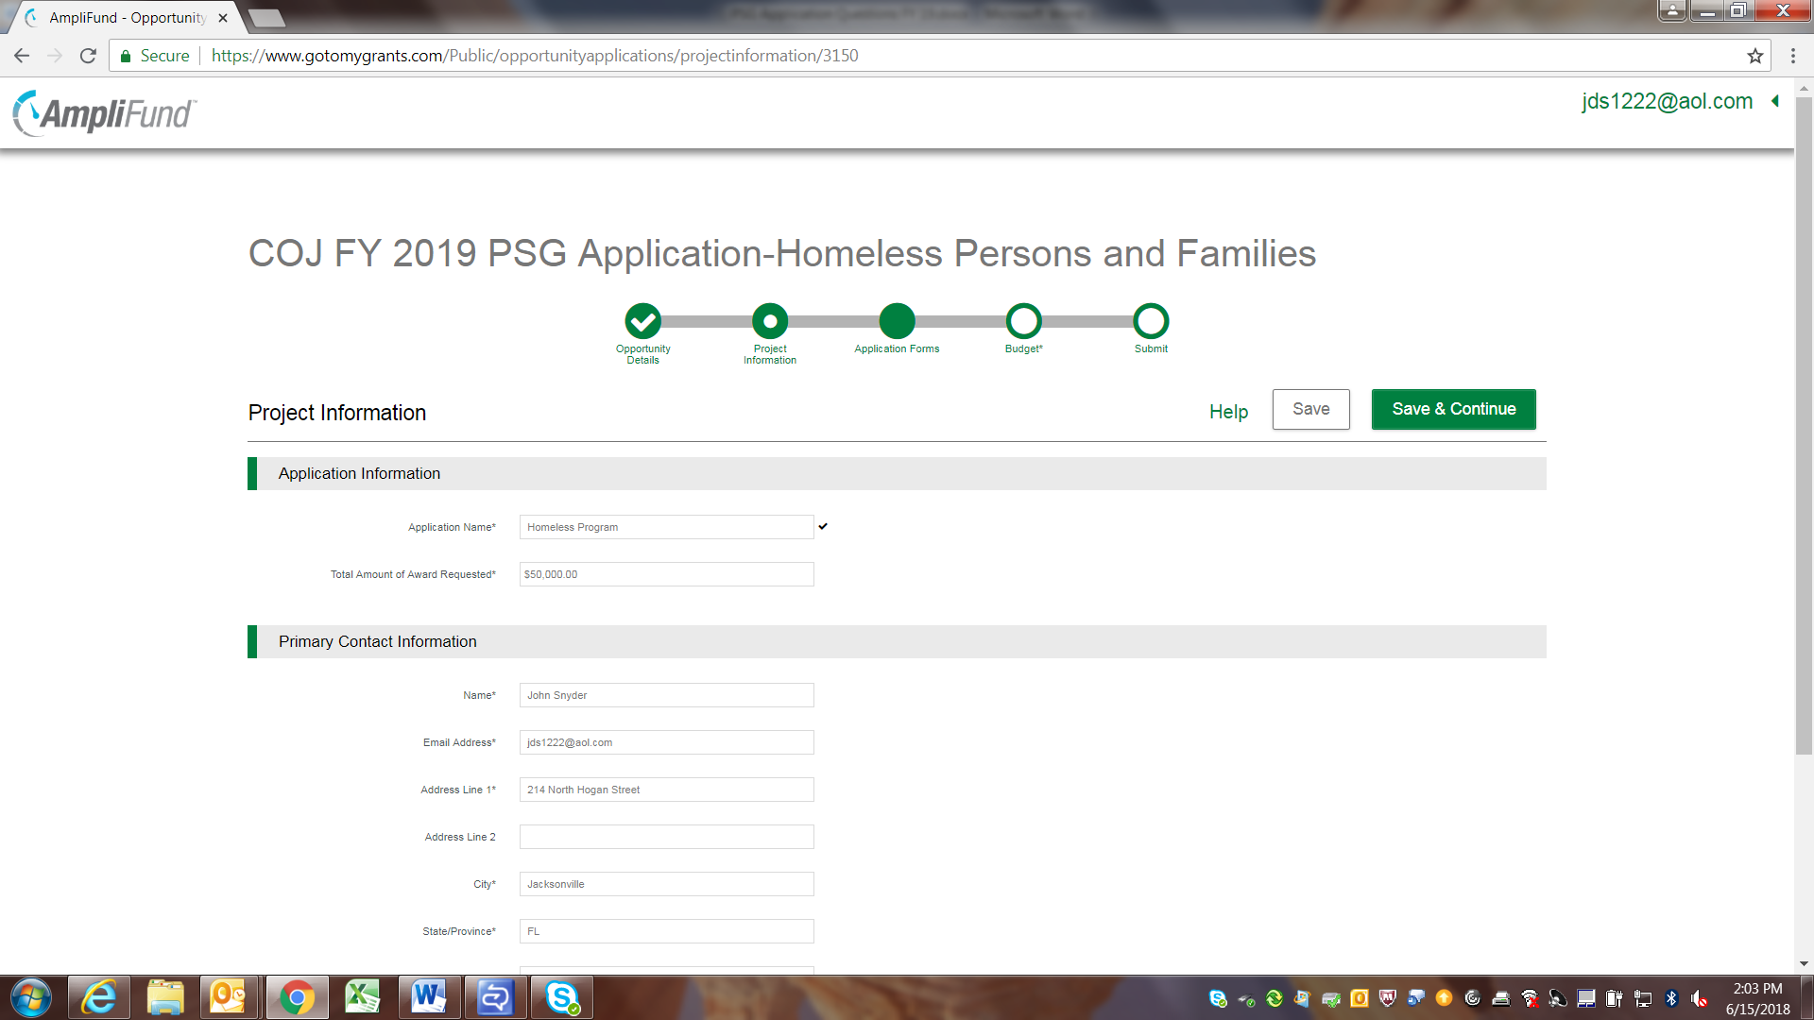

Can we put two different types of focuses on our grant application? I’m confused by the question?

1. Are you asking if your application/ program can have two focuses- However, you choose to write your application is up to you.

2. Are you asking if you application can focus on two separate priority populations? The answer to that is no.

Please advise if there is no need for me a new non-profit newly formed organization apply for the PGS with no history of tax returns filed. You have to be a non-profit in business with three year of tax returns to apply for PGS? Yes you are correct.

Can you provide more information on the Eligibility document titled "an original affidavit"? Please see attached Affidavit template and Ordinance 118.805(b)5 states: An original affidavit, in the form provided by the Office of General Counsel, executed by the requesting agency's executive director, chief executive or operating officer, president, vice president or board chairman certifying that:

(i) The requesting agency's program will be operated in Duval County and serve the people of the City;

(ii) The requesting agency's program will serve a Priority Population or Priority Need designated by the City Council for the grant application cycle in which the requesting agency is applying for;

(iii) The requesting agency's program is not eligible to receive funding from any of the City programs listed in Section 118.805(a)(1)—(7);

(iv) The requesting agency's appropriation request for multiple or single programs does not exceed in the aggregate 24 percent of the requesting agency's annual revenue (as shown on filed tax returns) averaged over the previous three tax years;

(v) The requesting agency is in compliance with the terms of all existing City agreements in which the requesting agency is a party; and

(vi) The requesting agency is in compliance with all applicable federal, state, local laws, rules, regulations and ordinances, as the same may exist and may be amended from time to time.

**Week of June 18, 2018**

I wanted to check about if the Corporate Resolution needs to be submitted with the PSG proposal. I did not see a place to upload it as a required document. Corporate Resolution is only required once you receive an award.

How will you determine we are serving the Priority Population we are providing fund to? If you are awarded funding, I will do a monitoring visit to see how your agency complies. You must be able to prove that you are serving the priority population you are seeking funding under.

We have applied in the past; however, not been awarded any funding and the person who applied left. How do we login? Just go ahead and register as a new applicant.

How do we get an office of general council affidavit? Is it having the CEO sign the attached & get notarized? See web-site for form and yes CEO signs it.

The last 3 years financial statements would be 2017, 2016 & 2015 but the application asks for revenue amounts to be filled in for 2016, 2015 & 2014. Should the financial records I upload be for those years as well? Some agencies file an extension by April 15 giving them until 10/1, so that is why we ask for 14-16; however, if you want to use 15-17 that is fine.   
  
And I take it they have to be scanned and uploaded as one file? Doesn’t seem to be a way to upload 3 files for that one requirement. Yes only one file upload

In this section toward the top of the cover page, what is meant by 24%? 24% of the 2,000,000+ allocated for Low Income Persons & Families? 2018-2019 PSG Requested Amount. (Are you over 24 %) (Whole Numbers Only) * You can only request a maximum amount of $150,000 or 24% of agency annual revenue of the last 3 years

I’m confused about the Budgets?

There are four things with the Budget;

1. The COJ Budget Form containing both
   1. Budget Detail-list all dollar figures to operation your program from all sources
   2. Budget Narrative- Narrative description of your PSG Request Only
2. Section V Budget in AmpliFund-Narrative description of ALL Funding to operate your program.
3. Budget part of application-This will be used if you are awarding funding
   1. First Click on Category to create (+) a Budget Category (Compensation, Occupancy Expense, Office Expense, Travel, Equipment, or Direct Client Expense).  Then click save
   2. Second create (+) budget line item under your category (Personnel, FICA & Med Tax, Dental, Health, Rent, Client Utilities, etc.)

The first + creates the category, the second time + creates the budget line item.

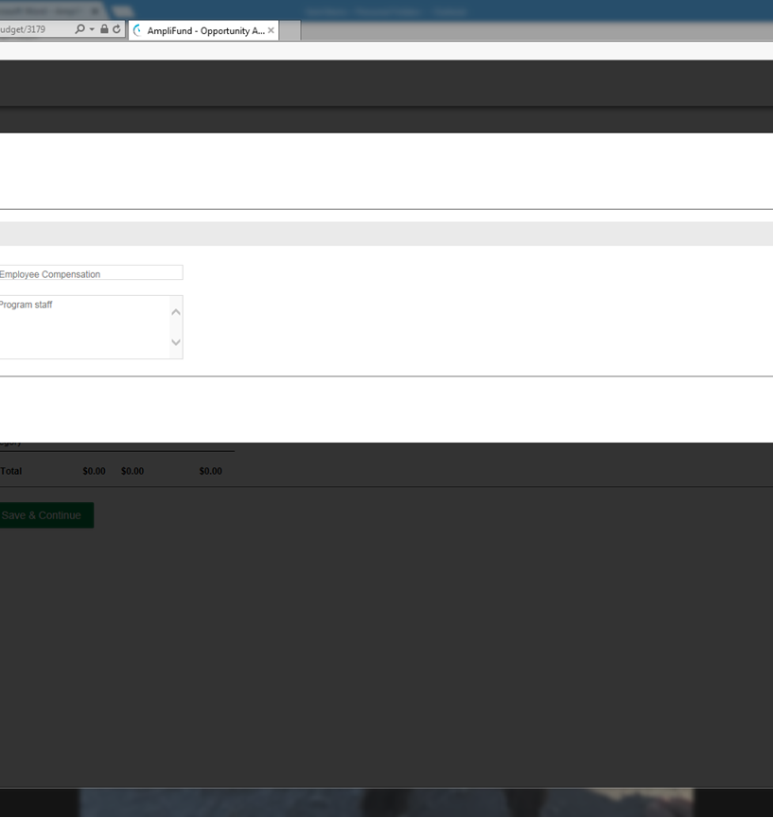

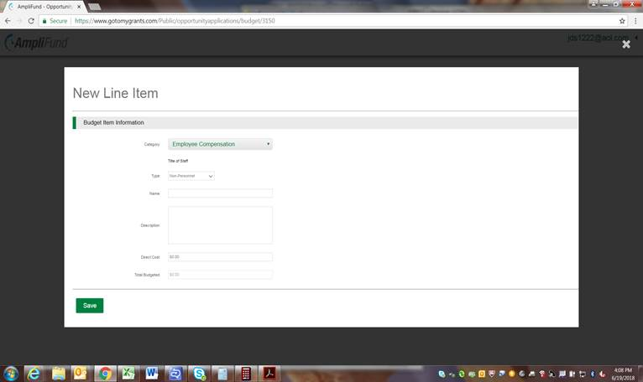

I have a question on the budget form for the 2018-2019 PSG application. Is the “Prior Year Funding FY-2016-2017” and “Current Year Budget FY-2017-2018” for PSG funding only or is it for the entire internal program budget from our agency? The COJ Budget Form is look at your whole program not just PSG funds but the cost and expenses for this program for prior years as well as proposed year.

For some reason, we have it in our heads that indirect cost is prohibited but I don’t have that in my notes or in the grant instructions. Is this accurate? Chapter 118.104h says indirect cost is disallowed:

“Non-Cash Expense means a non-cash charge to income (such as depreciation), an accrual for estimates (such as bad debt expense) and general overhead (such as indirect costs). Only General overhead, including specified allocations or items, is allowable as specified by contract.” Items must be spelled in budget such as; CEO or CFO Salary, Rent, utilities, postage, etc.

I wanted to check about if the Corporate Resolution needs to be submitted with the PSG proposal.  I did not see a place to upload it as a required document. Corporate Resolution is only required once you receive an award.

In regards to your question about travel, in the budget there is Local Mileage, this is for driving around locally.  Then there is travel, which is travel outside of Duval County.  Chapter 118.301 will not allow for travel mileage/ transportation outside of Duval County, accommodation, meals, & beverages.  However, the staff training budget line can pay for registration for training.  See Ordinance 118.301 for more details

<https://library.municode.com/fl/jacksonville/codes/code_of_ordinances?nodeId=TITVADPE_CH118CIGR>

I’m getting an error message after cutting and pasting (404 error). Try removing the CAP LOCKS

**Week of June 25, 2018**

What tact should I take with the certification of additional funding sources?  
The Certificate of Additional funding should match your budget.  If in your budget detail and section V you list other expenses for the program besides PSG then those sources of funding most come from somewhere (i.e. Agency, Federal, State, etc.).  There is no match requirement for PSG; however, we are just looking for a picture of your program.