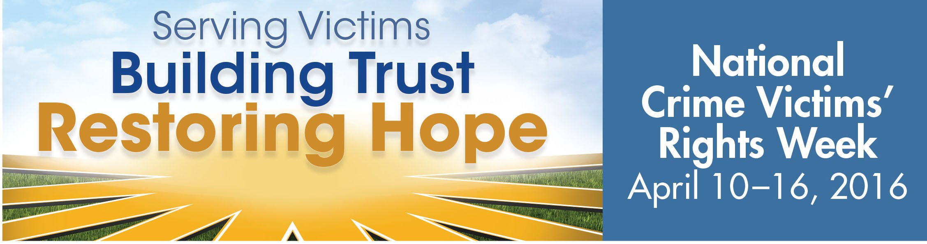

Monday, April 11th, 2016 – 11:30a.m.
Kickoff Press Conference
City Hall – St. James Building Atrium

Monday, April 11th, 2016 – 6:00 p.m.
Justice Coalition Tossing of the Roses
The Jacksonville Landing

Tuesday, April 12th, 2016 – 11:00a.m.
Resource Fair
Jacksonville Downtown Library

Tuesday, April 12th, 2016 – 12:00p.m.
Awards and Recognition Luncheon
Jacksonville Downtown Library

Thursday, April 14th, 2016 – 6:00p.m.
Compassionate Families Candlelight Vigil
Unity Plaza – 220 Riverside Avenue

Friday, April 15th, 2016 – 5:00p.m.
Families of Slain Children Balloon Release
3108 North Myrtle Avenue

For Victims’ Rights Week Events Information Contact:
Thelma Jackson at (904) 630-7103 or tjackson@coj.net
Like us at: www.facebook.com/savin.jax
Sponsored by: the Mayor’s Victim Assistance Advisory Council (VAAC)
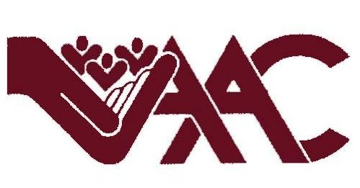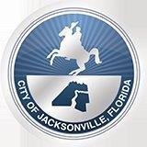
Sponsored by:
The Mayor’s Victim Assistance Advisory Council

Sponsored by:
The Mayor’s Victim Assistance Advisory Council

Sponsored by:
The Mayor’s Victim Assistance Advisory Council

