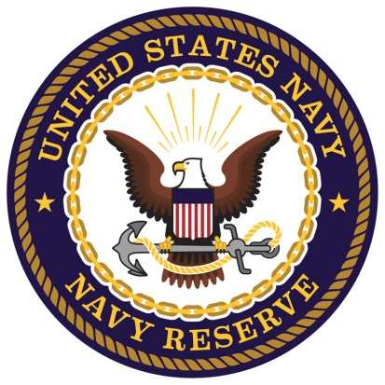
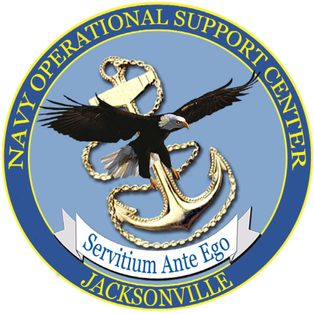

Patriotic Employer Hiring Event!!!
All Military Branches & Military Family Members are Invited!!!
WHEN: March 10th, 2018
WHERE: Naval Air Station Jacksonville
6801 Roosevelt Avenue
Jacksonville, FL 32212
TIME: 10:00 AM to 2:00 PM
Base Location: Hangar 117
Your Department of Defense employment initiative has invited many Patriotic Employers to meet you and discuss current job opportunities. Here are just a few of the employers that have committed to this Recruiting/Hiring Event, to date:
- Northrup Grumman
- Trident Refit Facility-Kings Bay
- BAE Systems
- Veterans Administration
- Starbuck’s
- Florida Power & Light
- Microsoft
- UPS
- Most Regional Law Enforcement Agencies
70+ military-friendly employers WANT TO HIRE YOU! Need help with your resume?
Penny Justice, Military Employment Advocate/Coach-Department of Defense,
CCD Career Connection at 904-553-0265; Penny.L.Justice@gmail.com.

