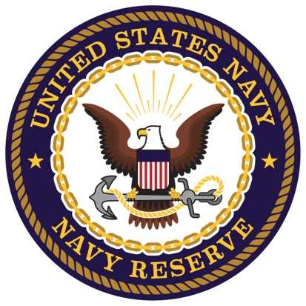
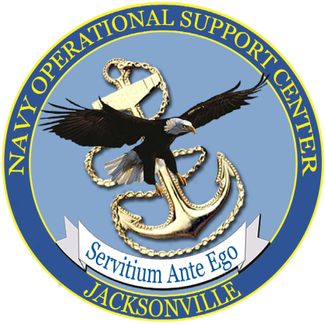

PATRIOTIC EMPLOYER
NAS/JAX Hiring Event!!!
You are invited to participate in our upcoming NAS/JAX Hiring Event!
Our Navy Reservists, throughout the Southeastern United States will be drilling this weekend and we expect to have maximum attendance.
Families and transitioning active duty & retirees will be attending, too!
All military branches, veterans & transitioning service members are invited.
WHEN: October 13th, 2018
WHERE: Naval Air Station Jacksonville
6801 Roosevelt Avenue
Jacksonville, FL 32212
TIME: 10:00 AM to 2:00 PM
Set-up 8:30 to 9:45
Base Location: Hangar 117
You must have current job listings to qualify for a free table at this event.
Please confirm at your earliest convenience. Email Penny Justice at: Penny.L.Justice@gmail.com to reserve your table(s).
Penny Justice, Military Employment Advocate/Coach-Department of Defense,
at 904-553-0265; Penny.L.Justice@gmail.com.

