Duval County

CHAIR
REPRESENTATIVE CLAY YARBOROUGH
VICE CHAIR
REPRESENTATIVE CORD BYRD

Legislative Delegation

SENATORS
AARON BEAN
AUDREY GIBSON

REPRESENTATIVES
CORD BYRD
TRACIE DAVIS
WYMAN DUGGAN
JASON FISCHER
ANGIE NIXON
CLAY YARBOROUGH

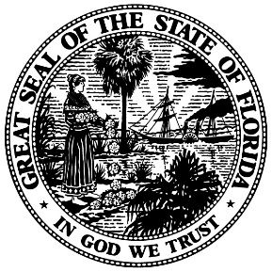

2021 PUBLIC HEARING
APPEARANCE RECORD

P L E A S E P R I N T

Please complete and email to hpataky@coj.net. If you do not receive a response within 2 days, please call the Delegation office (904-255-5105). This form and all material for the meeting must be received by November 18th, 2021.

Name of Speaker:

Contact Person:

Name of Organization:

Address:

City: Zip:

Phone: Type: Cell Office Home

E-mail:

Please select: Proponent Opponent Information

Do you have handouts? Yes No

Comments/request:

PLEASE COMPLETE AND RETURN TO DELEGATION COORDINATOR. PURSUANT TO ARTICLE I, SECTION 24 OF THE FLORIDA CONSTITUTION, THIS DOCUMENT, AND THE INFORMATION CONTAINED THEREIN, IS A PUBLIC RECORD.

