

630-CITY SMALL TREE LIST

**Yaupon Holly (*Ilex vomitoria*)**

Evergreen (does not drop leaves in winter)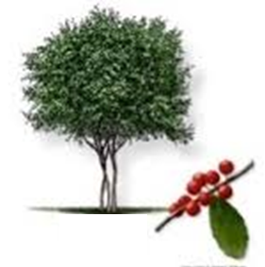

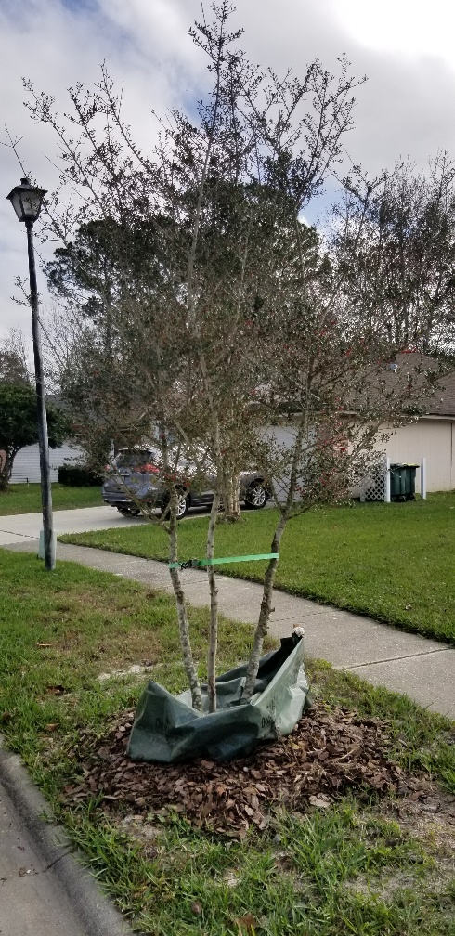A small sized, woody tree with very small green leaves and small clusters of white/green flowers in the spring. Following flowering, female specimens will have small, vibrant red berries that provide food for local wildlife, especially attracting birds.

**Little Gem Magnolia (*Magnolia grandiflora* ‘Little Gem’)**

Evergreen (does not drop leaves in winter**)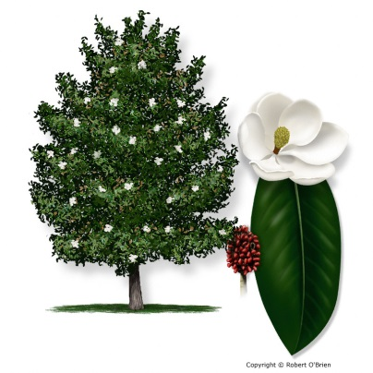

A small/medium sized tree with dark green leave and very showy, brilliant magnolia flowers that bloom in the spring/summer. This is a cultivar of the Southern Magnolia that stays fairly small and is slow growing. **Although the little gem magnolia is evergreen it will drop its leaves and can be messy in some homeowners’ opinions.

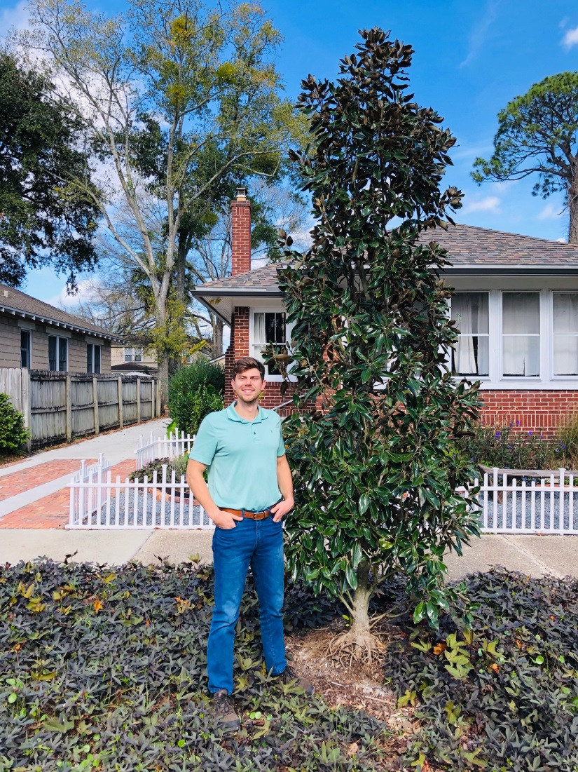

**Wax Myrtle (*Myrica cerifera*)**

Evergreen (does not drop leaves in winter) 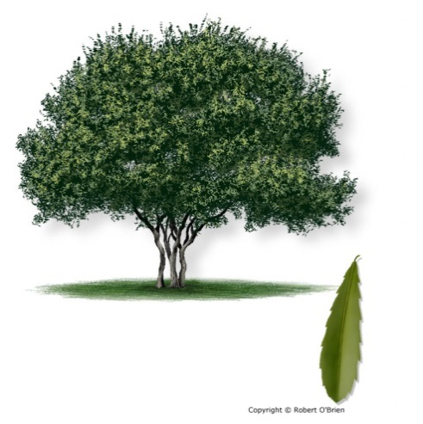

A small tree with green leaves and has a twisted trunk formation that also flowers and the females provide small blue berries that attract wildlife. Form can sometimes require regular maintenance in order to achieve tree form.

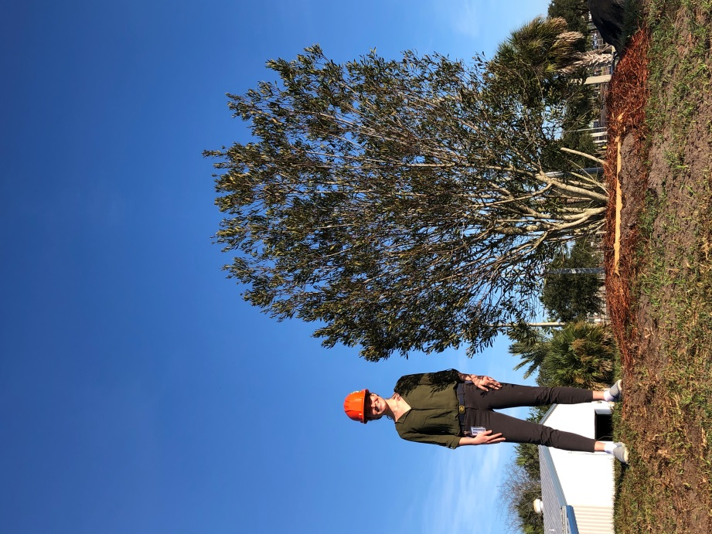

**Walters Viburnum (*Viburnum obvatum)***

Evergreen (does not drop leaves in the winter)

This native features a mass of small white flowers in the spring that attract butterflies, and its fall fruit attracts birds and other wildlife. Because their height is limited, viburnums are a good choice for street-side plantings and under powerlines. Walter's viburnum and sweet viburnum tolerate a variety of soil types, making them particularly drought-tolerant plants.

**Chaste Tree (*Vitus angus-castus)***

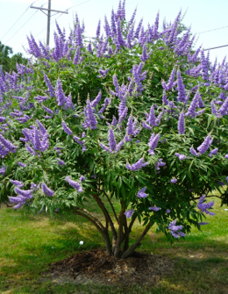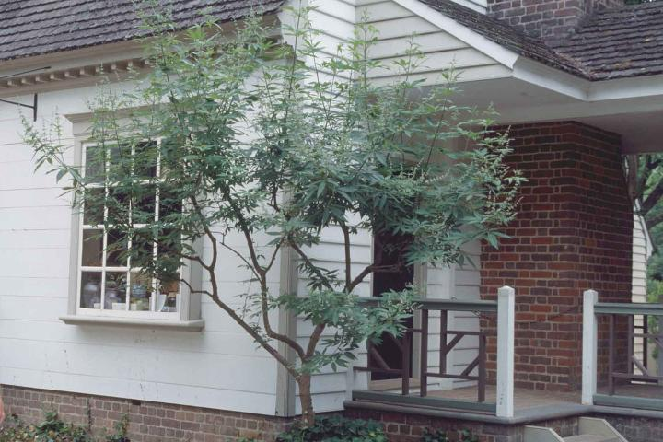

Deciduous (drops its leaves in winter)

Chastetree can be grown as a large, deciduous, multistemmed shrub or small, 10 to 15 feet tall tree, and is noteworthy for its showy, summer display (late springtime in the deep South) of fragrant, upwardly pointing, terminal panicles of lavender blooms which are quite attractive to butterflies and bees.