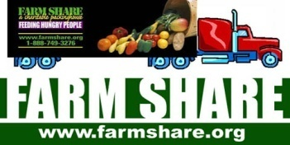
VA Outpatient Clinic
Brings you a Free Food Distribution
1536 N Jefferson St.
Jacksonville, FL 32209

December 4, 2018
9:00am - 12:00pm
Or until food is gone

Food is first come, first served.
*Please bring bags or containers to help carry multiple bags of food*
For questions please contact: 904-475-5882
Farm Share is an equal opportunity provider.

