

630-CITY Tree Planting Program Information

***What is 630-CITY Tree planting Program?***

The 630-CITY Tree Planting Program is a program set up by the City of Jacksonville’s Urban Forestry Team in order to use the [Tree Mitigation Fund](https://jaxtreemitigation.coj.net/) to plant up to two free trees on the City Right of Way. The City Right of Way is the area in front of the property that is owned by the City of Jacksonville and a staff member of our Urban Forestry team will determine if there is enough room as well as what the best species to plant based off of the location and factors like soil, light, space, any conflict with utilities, etc.

The Tree Mitigation Fund is an account of funding set up with the City of Jacksonville that can only be spent on planting trees within City Property. When landowners or developers request to cut down trees or clear land for building they must obtain a tree removal permit from the Building and Planning Department. Developers pay money into this fund for trees that are removed of certain size, species, etc. The City of Jacksonville’s Urban Forestry Team created this 630-CITY Program in order to reinvest this money from trees that have been removed into reforesting our city.

***Where are we allowed to plant trees?***

* The right of way is the space at the very front of your yard that the city maintains ownership of in order to have a place for utilities.
* As we are only allowed to plant trees within public property (including the right of way), the size and location of this right of way is extremely important in our decision of where we plant and what species we can plant.
* The boundaries of right of way areas generally follow these rules:
  + If there is a sidewalk, the right of way is between the sidewalk and the street.
  + If not, the utility that is furthest set back will generally be the limit of how far back the right of way goes.
    - This utility could be water meters, power lines, street lights, or junction boxes from underground utilities.
* If the right of way area is questionable, our team will search the right of way distance on our computer and measure this distance during a site visit.
* It is extremely important to remember that we are only able to plant within right of ways and therefore in some cases, the size and shape of a right of way may impact our ability to plant at your requested location.

***How is the site visit conducted?***

*What do we look for when we complete a site visit of the right of way near your home? Seeing any of these factors on street view programs may warrant a site visit being required.*

* Overhead utility lines
* Existing trees and their locations
  + Location of existing and future tree canopy
* How much room there is within city right of way
* What trees will thrive long-term in that location
* Overhead street lights
* Drainage ditches
* What trees do well in the surrounding area, allowing us to better understand what would do well there
* Sunlight and water need considerations

***How does the process work for the city to plant trees for me?***

1. Citizen calls 630-City call center to request trees planted on the right of way near their home or requests trees online.
2. City forester receives requests and divides them by city council district.
3. City forester then reviews these requests within each district and determines eligibility for the program.
   1. Many sites can be reviewed using google street view and satellite maps when no extenuating circumstances exist (a list of the possible reasons follows on the next page).
   2. If the forester is not able to determine eligibility solely on computer programs, they will complete a site visit. They will use the following page’s information to evaluate the site.
   3. Some sites will unfortunately not be eligible to receive a tree due to any of the causes on the next page or right of way laws. We do appreciate all requests though and are more than happy to evaluate each case.
4. After a determination has been made as to what tree would be beneficial at each site (for that location and the urban forest as a whole), the forester or an intern will reach out to each homeowner that completed a request.
   1. This contact will be made by telephone when a telephone number is available, and the employee will leave a brief message with a call back number.
   2. **IMPORTANT:** If the forester does not receive a call back within a timely fashion (approximately 2-4 weeks) they will have to close the ticket. This is purely to allow us to process the high amount of requests in a timely manner.
   3. If a request is closed due to not being able to create contact, please feel free to call 630-City and request trees again.
5. Confirmed requests are then rounded up by city council district and given to our contractor to complete the plantings.
6. Our contractor will then order the trees from a wholesale tree farm and have them delivered (a process that can take up to one month).
7. Our contractor will then begin planting trees, dividing up their plantings by city council district to keep them geographically centralized.
8. After your tree has been planted a water bag will remain around the trunk for the first three months after planting. During this time we have a warranty on the tree as well. If you have any questions about watering or caring for your tree you can call 630-City to have us reach out to you.
9. After three months, the warranty expires and the water bag will be collected. You now have a free tree planted in your right of way!

***What tree species does the City Plant?***

You can find our approved tree list for 630-CITY trees on Coj.net/trees under the ‘resources’ tab, link below:

630-CITY Small Tree List

630-CITY Medium Tree List

630-CITY Large Tree List

* There is a high standard for the trees that are planted for this program and the trees must meet top quality standards to be selected and planted for the 630-CITY Program. All trees must be Florida Fancy or No. 1 which is the highest grade of nursery stock when selecting trees. The trees that are planted are 3” caliper trees meaning they are 3” in diameter at the base of the tree, putting them around 8-14 feet tall depending on the species that is planted. Most trees planted are bagged and burlapped, meaning the trees are grown in the field and dug up before planting and wrapped in a burlap bag and harden off before planting in order to achieve maximum establishment and survivability.

**How the tree planting process is conducted:**

1. The planting contractor will find the flagged location for tree that has been selected based off the homeowner preference as well as expertise by a member of the Urban Forestry Team. Before any digging is conducted, the contractor calls in locates for any underground utilities such as water, electric, phone, cable, internet, etc. as not to hit any critical infrastructure. Based on the utility locates, the tree might end up being moved as to not interfere with any of those utilities.
2. 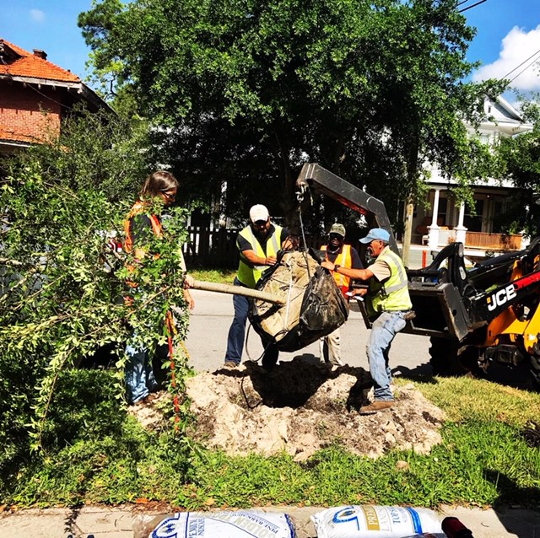The contractor will then dig the hole by hand deep enough and wide enough for the tree to have plenty of room to establish properly.
3. After getting the tree installed into the hole, the contractor will mix up some new planting soil along with the excess soil when they dug for the planting.
4. After installed and the soil has been returned to the hole and the planting area level with the ground, the contractor will install wooden stakes through the rootball in order to secure the tree in place. The City uses this staking method because the regular straps that are used on other tree plantings can be harmful over time if not taken down. These wooden stakes will decay over time and do not need to be removed, over time providing a healthier tree and less maintenance for the property owner as well as the City of Jacksonville.
5. 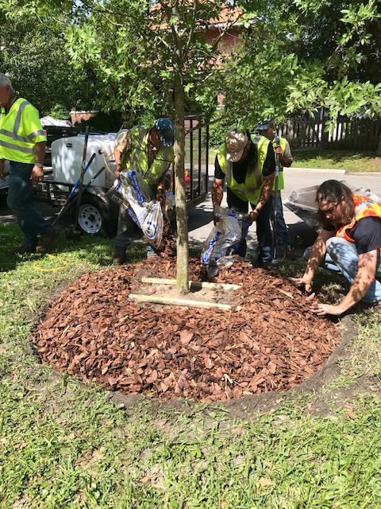After the wooden stakes are installed, the contractor will place a ring of mulch over the stakes and around the rootball. A watering bag will be installed over the mulch and filled up with water.
6. When requesting free trees to be planted by the city, the one thing we do ask is that you keep the water bag full for the first three months after installation. The contractor will come out after three months to make sure that the tree is still alive and remove the watering bag from the tree. It is still a good idea to continue to keep the tree watered after the contractor removes the watering bag.
   1. There will also be a small tree tag tied around the tree to let you know what type of tree it is with a small instruction list. Please take this tag off of the tree once the contractor has finished installing the tree.

