

630-CITY Tree Planting Program Information

***What is 630-CITY Tree planting Program?***

The 630-CITY Tree Planting Program is set up by the City of Jacksonville’s Urban Forestry Team in order to use the [Tree Mitigation Fund](https://jaxtreemitigation.coj.net/) to plant up to two trees on the City Right of Way in front of residential and commercial properties. The City Right of Way is the area in front of the property that’s owned by the City of Jacksonville. A staff member from our Urban Forestry team will determine if there’s enough room as well as what the best species to plant based off of the location and factors like soil, light, space and any conflict with utilities, etc.

The Tree Mitigation Fund is an account utilized by the city for the sole purpose of planting trees. When landowners and developers clear land for building they must obtain a tree removal permit from the City. This mitigation fee is then utilized by the city to plant trees in an attempt to offset the additional environmental stresses from deforestation including air pollution, erosion, Stormwater runoff and much more. The City of Jacksonville’s Urban Forestry Team created the 630-CITY Tree Planting Program in order to reinvest this money from trees that have been removed into reforesting our city.

***Where are we allowed to plant trees?***

* The right of way is the space at the very front of your yard that the city maintains ownership of in order to have a place for public utilities.
* As we are only allowed to plant trees within public property (including the right of way), the size and location of this right of way is extremely important in our decision of where we plant and what species we can plant.
* The boundaries of right of way areas generally follow these rules:
  + If there is a sidewalk, the right of way is typically between the sidewalk and the street.
  + If there is no sidewalk, the utility that is furthest set back will generally be the limit of how far back the right of way goes.
    - This utility could be water meters, powerline poles, street lights, or junction boxes from underground utilities.
* 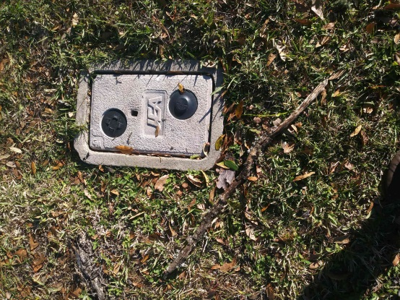**It’s important to remember that we’re only able to plant within city right-of-ways therefore, the size and shape of a right of way may impact our ability to plant at your requested location. We cannot plant trees on private property.**

***How is the site visit conducted?***

*Seeing any of these factors on Google street view will warrant a site visit from our urban forestry team.*

* Overhead utility lines

**Water Meter**

* Proximity to existing tree canopy
* Right-of-way space
* Street lights
* Other municipal infrastructure including, drainage ditches, sewers etc.
* Proximity to intersections and street signs

***How does the process work for the city to plant trees for me?***

1. Citizen calls 630-City to request a tree.
2. Urban forestry team receives request and divides them by city council district.
3. Urban forestry team reviews requests within each district and determines eligibility for the program.
   1. Many sites can be reviewed using Google street view and satellite imagery. When extenuating circumstances exist a site visit will be made.
   2. Unfortunately not all sites will be eligible to receive a tree. Limited right-of-way space, privately owned roads and other factors may result in tree request being denied.
4. After a site has been approved for a tree, a representative from the urban forestry team will contact you.
   1. Contact will be made by telephone when a telephone number is available, and the employee will leave a brief message with a call back number.
   2. **IMPORTANT:** Due to high volume of requests, if the forester does not receive a call back within a timely fashion (approx 2-4 weeks) they will close the ticket.
   3. If we have closed the ticket because we were unable to contact you, please feel free to call 630-City and request trees again.
5. Confirmed requests are then organized by city council district and given to our contractor for planting.
6. Contractor will then order trees from a wholesale tree farm and have them delivered (a process that can take up to one month).
7. Contractor will then begin planting trees, dividing up their plantings by city council district to keep them geographically centralized.
8. After your tree has been planted a water bag will remain around the tree trunk during the warranty period of 3 months. If you have any questions about watering or caring for your tree you can call 630-City and have us reach out to you.
9. After 3 months, the warranty expires and the water bag will be collected. You now have a free tree planted in your right of way!

***What Tree Species Does the City Plant?***

You can find our approved tree list on Coj.net/trees under the ‘resources’ tab, link below:

630-CITY Small Tree List

**630-CITY Medium Tree List**

**630-CITY Large Tree List**

* Trees planted for this program must meet top industry standards for quality. All trees must be Florida Fancy or No. 1 which is the highest grade of tree nursery stock when selecting trees. The majority of tree species planted are 3” in caliper. This means the trunk is 3” in diameter when measure 6” above the rootball. They’re typical between 8’-12’ tall depending on species. Most trees are balled and burlapped (B&B), meaning the trees are grown in the field and dug out with a tree spade, wrapped in a burlap bag and hardened off before planting in order to achieve maximum survivability.

**How the Tree Planting Process is Conducted:**

1. The planting contractor will find the flagged location for tree that’s to be planted. Before any digging begins the contractor calls in locates for any underground utilities such as water, electric, phone, cable, internet, etc. Based on the utility locates, slight field adjustments in planting location might be required.
2. 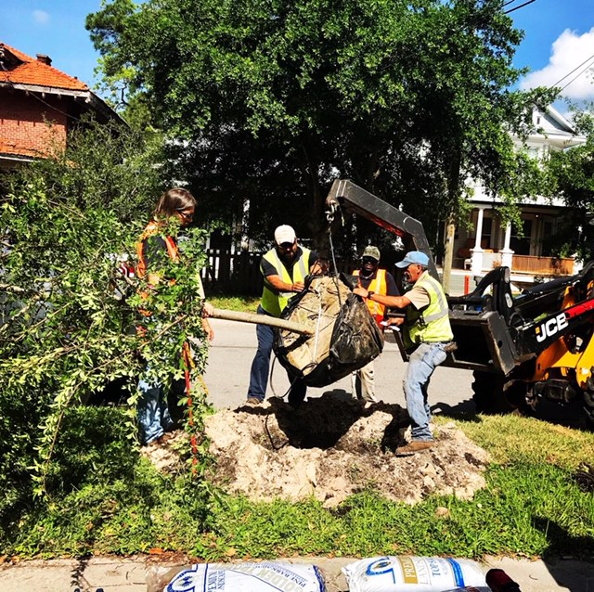The contractor will then dig the hole by hand deep enough and wide enough for the tree to have plenty of room to establish properly.
3. After getting the tree installed, the contractor will mix up some new planting soil along with the excess soil when they dug for the planting.
4. The contractor will then install wooden stakes through the rootball in order to secure the tree in place. These wooden stakes will decay over time and do not need to be removed, providing a healthier tree and less maintenance for the property owner as well as the City of Jacksonville.
5. 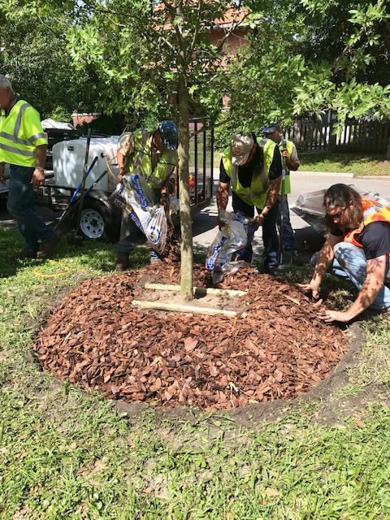After the wooden stakes are installed, the contractor will place a ring of mulch over the stakes and around the rootball. A watering bag will be installed over the mulch and filled up with water.
6. When requesting free trees to be planted by the city, the one thing we do ask is that you keep the water bag full for the first three months after installation. The contractor will come out after three months to make sure that the tree is still alive and remove the watering bag from the tree. It’s still a good idea to continue to keep the tree watered after the contractor removes the watering bag.
   1. There will also be a small educational tag tied around the tree informing you of the tree species as well as proper tree care. Please take this tag off once the contractor has finished installing the tree.

