

630-CITY SMALL TREE LIST

**Crape Myrtle – (*Lagerstroemia* spp.)**

Deciduous (drops leaves in winter) 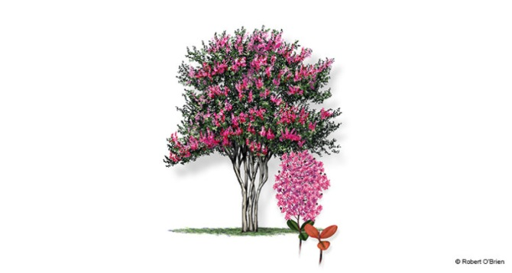

A small sized tree used around the southeastern United States as a common garden and urban tree. It has been bred over thirty years and comes in a verity of different hybrids and varieties; ranging in height and color. Summer flowers are showy and can be pink, lavender, purple, red, or white. It is a very tolerable species and hardy in most planting locations.

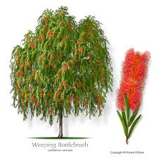**Bottlebrush – (Callistemon spp.)**

Evergreen

Named for its showy flowers this small tree is a beautiful evergreen shrub/tree that will have long flower spikes that resemble bottlebrushes. The red flowers attract hummingbirds and butterflies. This tree is very hardy and can tolerate most urban planting conditions.

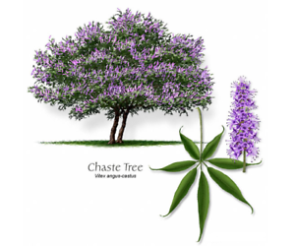**Chaste Tree – (*Vitex agnus-castus)***

Deciduous (drops leaves in winter)

The chaste tree, or Vitex, is a small shrub/tree that has dark green leaves and will have very showy purple or lavender flower spikes in late spring/early summer. It is a small tree that will attract pollinators.

**Eastern Redbud – (*Cercis canadensis*)**

Deciduous (drops leaves in winter) 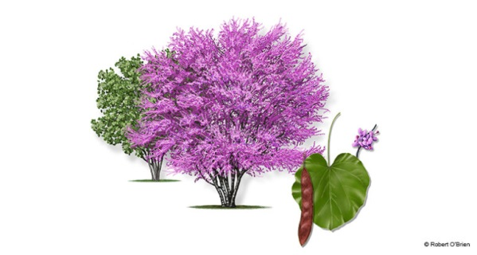

A small sized fast growing tree with heart shaped and spectacular purple/pink flowers that bloom in early spring. These trees can tolerate full sun but prefer some shade in the Florida summers.

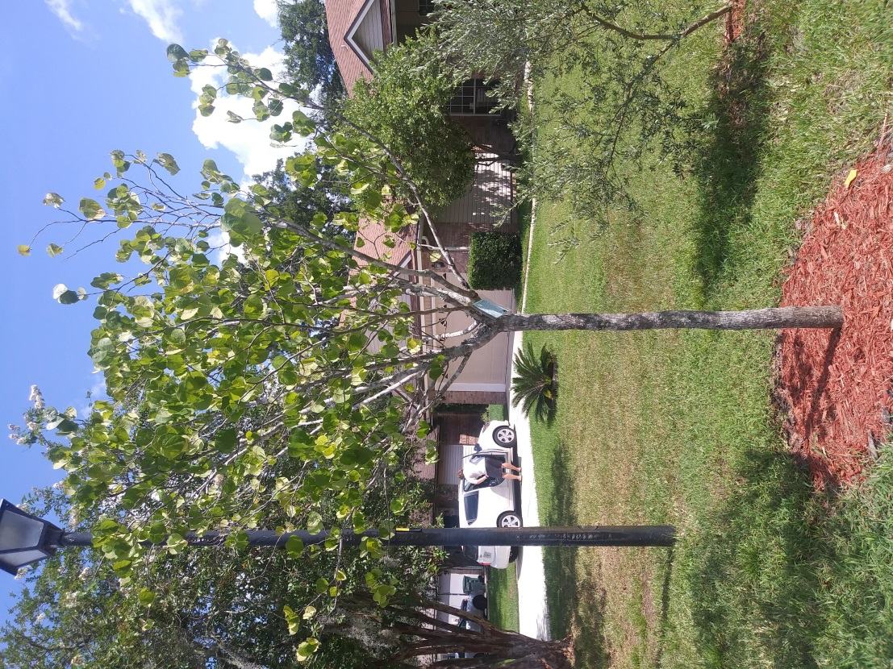

**Fringe Tree – (*Chionanthus virginicus*)**

Deciduous (drops leaves in winter) 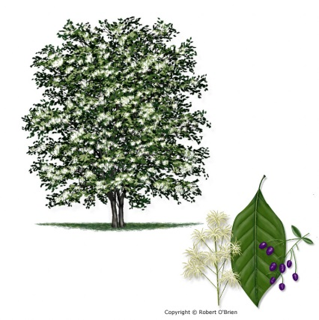

A slower growing, small tree with beautiful white flowers that bloom in spring.

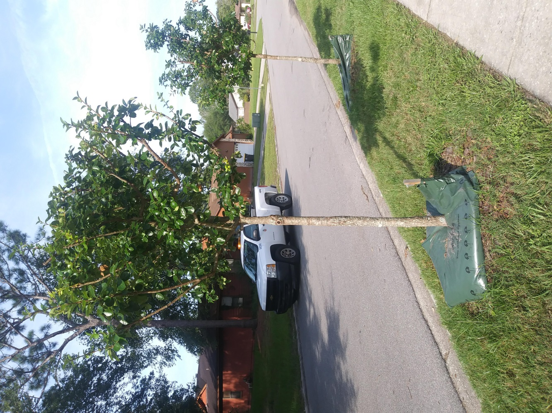

**Yaupon Holly (*Ilex vomitoria*)**

Evergreen (does not drop leaves in winter)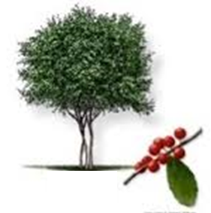

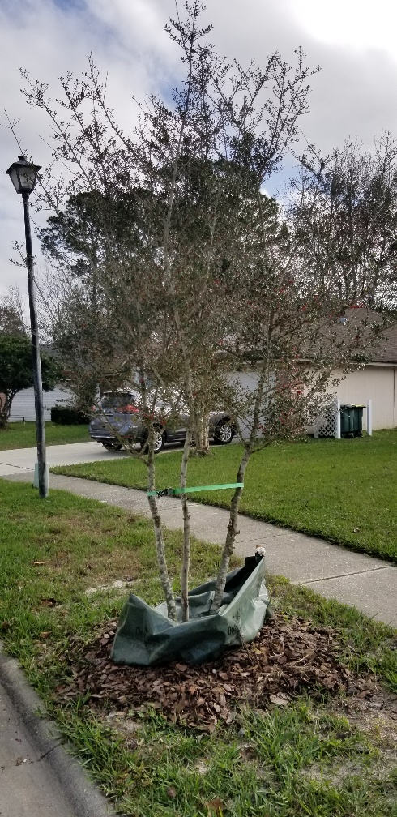A small sized, woody tree with very small green leaves and small clusters of white/green flowers in the spring. Following flowering, female specimens will have small, vibrant red berries that provide food for local wildlife, especially attracting birds.

**Little Gem Magnolia (*Magnolia grandiflora* ‘Little Gem’)**

Evergreen (does not drop leaves in winter**)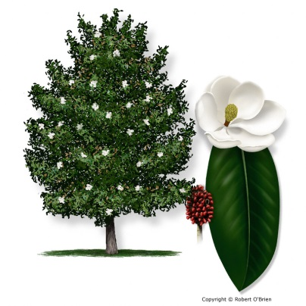

A small/medium sized tree with dark green leave and very showy, brilliant magnolia flowers that bloom in the spring/summer. This is a cultivar of the Southern Magnolia that stays fairly small and is slow growing. **Although the little gem magnolia is evergreen it will drop its leaves and can be messy in some homeowners’ opinions.

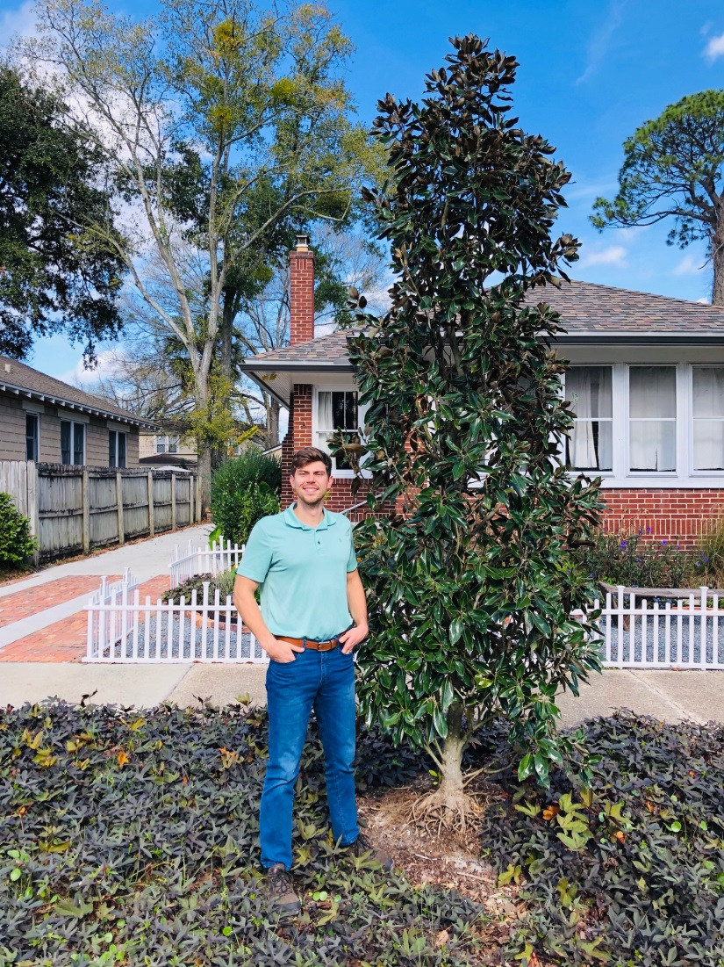

**Wax Myrtle (*Myrica cerifera*)**

Evergreen (does not drop leaves in winter) 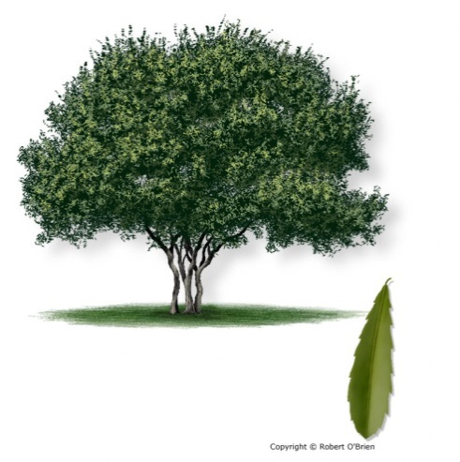

A small tree with green leaves and has a twisted trunk formation that also flowers and the females provide small blue berries that attract wildlife. Form can sometimes require regular maintenance in order to achieve tree form.

