**Eastern Redbud – (*Cercis canadensis*)**

630-CITY SMALL TREE LIST

Deciduous (drops leaves in winter) 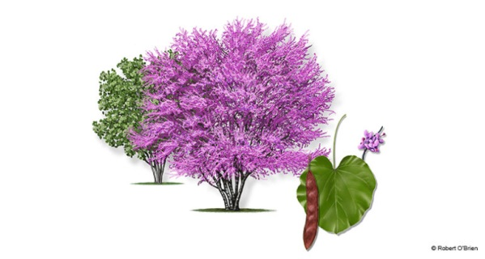

A small sized fast growing tree with heart shaped and spectacular purple/pink flowers that bloom in early spring. These trees can tolerate full sun but prefer some shade in the Florida summers.

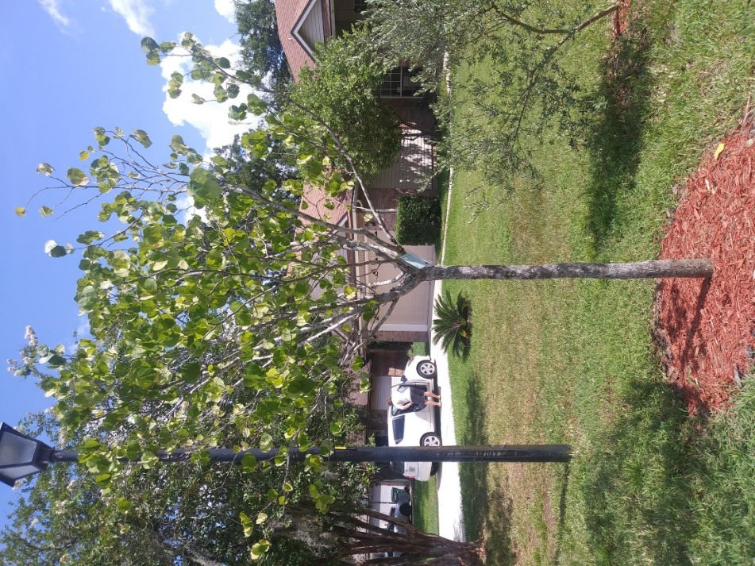

**Yaupon Holly (*Ilex vomitoria*)**

Evergreen (does not drop leaves in winter)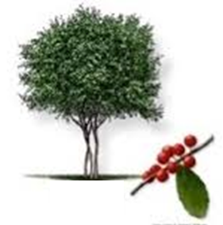

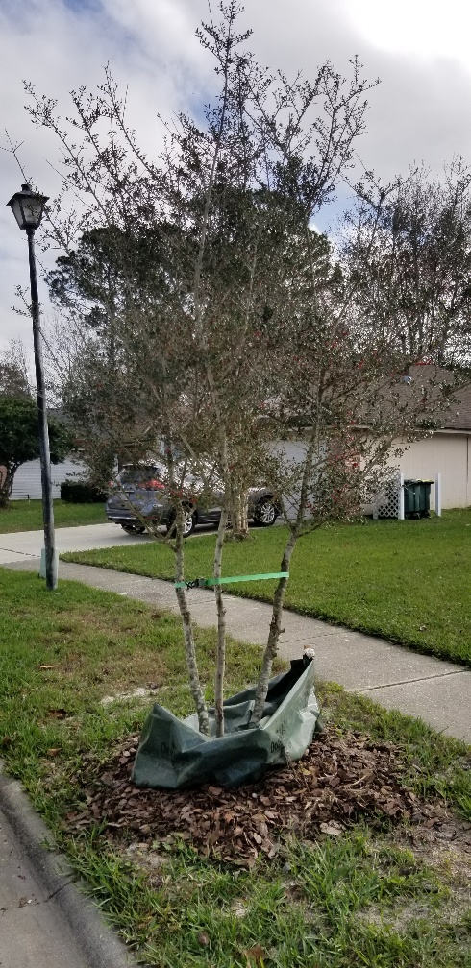A small sized, woody tree with very small green leaves and small clusters of white/green flowers in the spring. Following flowering, female specimens will have small, vibrant red berries that provide food for local wildlife, especially attracting birds.

**Little Gem Magnolia (*Magnolia grandiflora* ‘Little Gem’)**

Evergreen (does not drop leaves in winter**)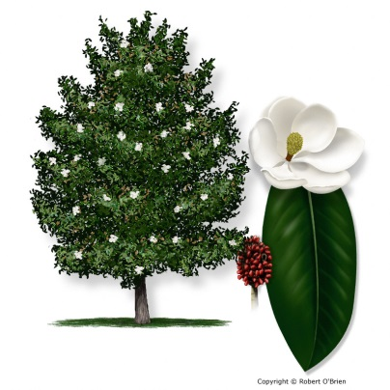

A small/medium sized tree with dark green leave and very showy, brilliant magnolia flowers that bloom in the spring/summer. This is a cultivar of the Southern Magnolia that stays fairly small and is slow growing. **Although the little gem magnolia is evergreen it will drop its leaves and can be messy in some homeowners’ opinions.

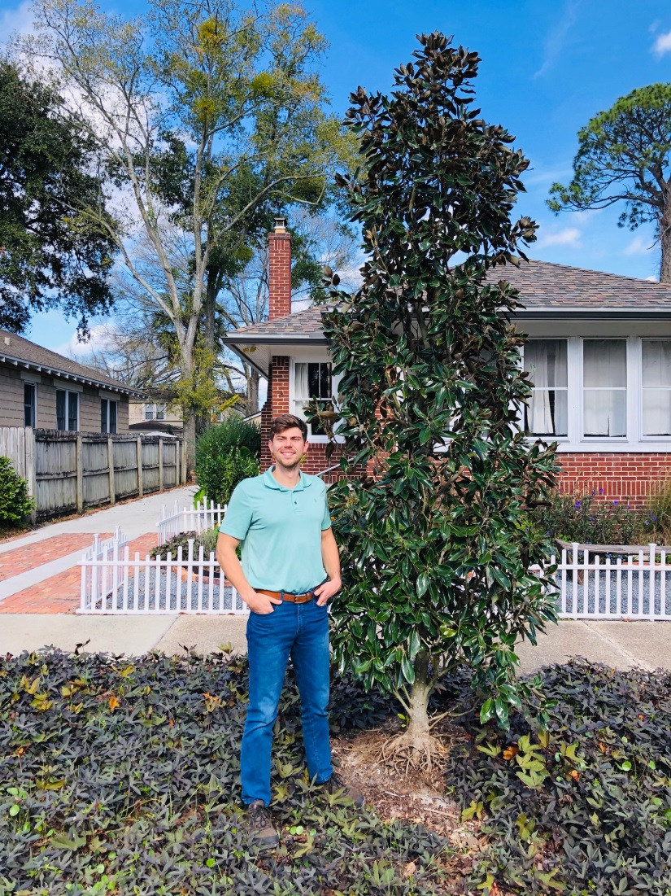

**Wax Myrtle (*Myrica cerifera*)**

Evergreen (does not drop leaves in winter) 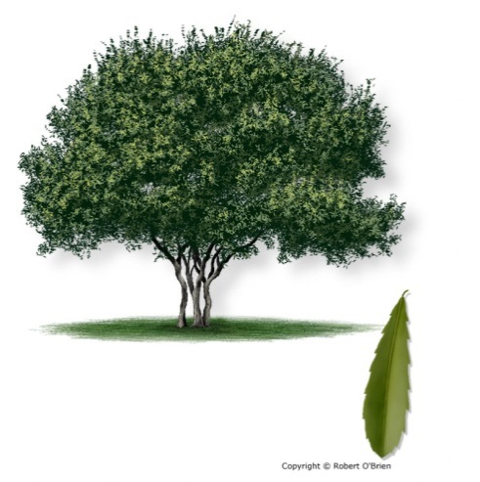

A small tree with green leaves and has a twisted trunk formation that also flowers and the females provide small blue berries that attract wildlife. Form can sometimes require regular maintenance in order to achieve tree form.

