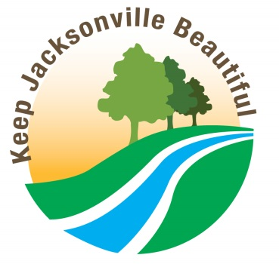
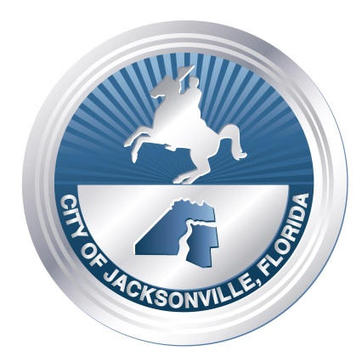
The City of Jacksonville & Keep Jacksonville Beautiful Presents
The Fourth Annual
Earth Day Downtown Cleanup

8 a.m. – 10 a.m.
Saturday, April 23

Meet on the steps of
The Jacksonville Landing

For Information, call: 630-3420

